

De La Salle University

College of Computer Studies

Software Technology Department

**Giovana Boutique**

SOFTWARE REQUIREMENTS SPECIFICATION

|  |  |
| --- | --- |
| **Team Name** | Team Hiroki |
| **Section** | S11 |
| **Team Members** | Arevalo, Mark Anthony A.  Asaba, Hiroki M.  Chuasang, Carvin  Co, Nikki R.  Corpuz, Paulo Neil E.  Gaw, Walchester S.  Lim, Patricia M.  Matias, Glenn M.  Santos, Kit D.  Shen, Andric Michael L. |
| **Date Submitted** |  |

**Table of Contents**

|  |  |
| --- | --- |
| 1. Executive Summary | 1-3 |
| 1. Overview | 2-4 |
| * 1. Existing Business Process | 2-4 |
| * 1. Data Requirements | 2-5 |
| * 1. Roles in the Business Process | 2-6 |
| 1. Problem Analysis | 3-8 |
| 1. Software Solution | 4-9 |
| * 1. Objectives | 4-9 |
| * 1. Characteristics | 4-9 |
| 1. User Stories | 5-10 |
| * 1. <User Story 1>   2. <User Story 2>   3. <User Story 3>   4. <User Story 4>   5. <User Story 5>   6. <User Story 6>   7. <User Story 7>   8. <User Story 8>   9. <User Story 9>   10. <User Story 10> | 5-11  5-12  5-12  5-13  5-13  5-14  5-14  5-15  5-16 |
| Appendix A - Improved Business Process | A-17 |
| Appendix B - Interview Transcript | B-18 |
| Appendix C - Sample Forms and Reports | C-39 |
| Appendix D - References and Acknowledgements | D-43 |

1. **Executive Summary**

Giovana is a fashionable clothing company that gets its products selected by their founder, Geraldine O. Macavinta, from abroad usually in these countries: Hong Kong, China, Thailand, and South Korea. The company caters to women, specializing on cocktail, formal dresses, blouses, and fashion accessories.

The company has 5 retail branches and 3 retail and wholesale branches. The 5 retail branches are the Cinderella branches that the company supplies to, and the 3 other branches are located at Baclaran and 168 shopping mall. In the 3 retail and wholesale branches, the company records and computes their sales and inventory manually in different logbooks depending on the category.

Once an item is sold, the item’s information is recorded in the daily logbook by the saleslady or owner. At the end of every day, the owner totals the sales. At the end of the every month, the owner totals the daily sales. This is to find out the total sales per month, which is subtracted from the capital that company set in the beginning of the month to find out how much net profit was made. Once the net profit is known, the owner can decide how much of the net will be used for the capital for the next month.

https://www.facebook.com/giovanaclothing

1. **Overview of the Business Process**

This chapter presents the company’s business process and goals as an organization/department. Included in this chapter are the following items:

* Description of the company's existing process and business requirements.
* Data requirements as part of the business process, including data that are captured, stored and generated.
* Different roles in the business process
  1. **Existing Business Process**

The process starts with the client going abroad to purchase the products to be sold in the different branches of Giovana here in the Philippines. The products will then be shipped and the client will check the invoice and compare it to the actual items delivered.

The client will then check if there are any discrepancies between what was listed in the invoice with what was actually received. If discrepancies were found, the client will contact the supplier in order to resolve the issues that were found in the invoice. Otherwise, the products will be added to the inventory then sent to the branches of Giovana to be sold.

The process of depositing occurs simultaneously with the process of selling. Once the respective branches open, the employees will start to sell the products while the client visits the various branches and deposits the money earned from the previous day.

When a product is sold, the employee will record the transaction in the logbook. Every branch has its own corresponding logbook that the client keeps track of. At the end of the day, an employee will tally the total sales and number of pieces sold for the day. Afterwards, the total expenses for the day will be subtracted from it which will be equivalent to that day’s net sales. The inventory will also be updated by subtracting the number of items sold. If an error(s) is found in the tally, the client will inspect the logbook and try to identify where the error originated. After the source of the error has been found the client will then talk to the employee who committed it and resolve the problem that arose from the error.

After all problems have been resolved with the total sales, a deposit slip will be made. The client will then deposit the money earned into the bank the following day. However, if the client is not present at the moment the employees must wait until the client is available so that the client can inspect the total sales and then deposit the money.

At the end of every month the client will tally the total sales for the current month and subtract the monthly capital from the total sales in order to get that month’s net sales. Afterwards, the client will check if the inventory still has a sufficient amount of products to last for the following month. In the event that the remaining products are insufficient, the client will schedule for a trip abroad in order to purchase more products.

At the end of the year, the client will tally the total sales for each month of the current year of each branch which will be the total earnings for that year.

*The business process can be visualized in the diagram shown in Figure 2-1.*

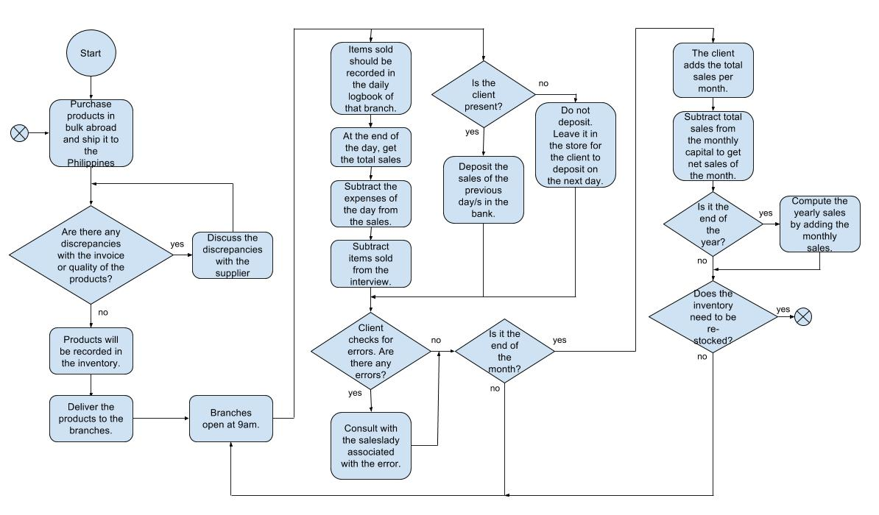

*Figure 2-1. Existing Business Process*

* 1. **Data Requirements**

An invoice that is received after purchasing items from abroad which lists the items that will be added to the inventory/storage. The invoice contains the number of items bought, its respective types and the corresponding prices.

A daily logbook contains the date when the item was sold, which day of week it was, the quantity of the item that was sold, the type of the item that was sold, the item’s selling price (the price may vary depending on if it was sold on wholesale or retail), the name of the employee who sold the item and the total sales for that day.

Another logbook that contains all sales that has been generated all throughout the month or year. This includes the deposit slips (stapled to the logbook) the computation of the Gross and Net sales and the total net sales of the bazaar that took place that month or year.

A yearly logbook contains the period covered (per month e.g. 2/21→ 3/19), the branch name and its total sales for that month, the total sales for a bazaar on that month if one was attended, the gross and the net sales.

In a separate sheet of the yearly logbook contain the list of bazaars attended. There can be multiple bazaars attended in a month or none; it is up to the discretion of the client if she wants to attend. The information contains when the bazaar occurred (e.g. 2/9-10), its organizer, the area/place, and the total sales for that bazaar; the rent and salary are counted as a single expense, the net sales and monthly average for all the bazaars of that year.

* 1. **Roles in the Business Process**

*Various employees are involved in the business process of inventory and sales management of Giovana. The roles of these employees and their tasks are summarized in Table 2-1.*

|  |  |
| --- | --- |
| Role | Description of Tasks |
| *Owner(Store Manager)* | * *Every month* * *Gets a fixed amount of capital* * *Estimates the quantity number of stocks to get* * *Goes abroad to buy clothes, accessories, and etc.* * *Logs the period covered for the inventory in the Yearly Sales logbook* * *Logs the amount of capital she brought to the country, if the stocks are delivered* * *Logs the total sale for the day in the Monthly Sales logbook* * *Logs the amount deposited in the Monthly Sales logbook* * *Calculates the total sales for the Month* * *Logs the total sale in the Monthly Sales logbook* * *For the transactions in the wholesale/retail stores* * *Recalculates the sale in the Daily Sales logbook and checks if the amount is equal to the cash to be deposited* * *Deposits the daily sale in the bank at the end of the day* * *Staple the deposit slip in the Daily Sales logbook* * *For the transactions in the retail stores* * *Records the quantity bought in the Daily Sales notebook* * *Records the item bought in the Daily Sales notebook* * *Calculates the total sale for the day and record in the Daily Sales notebook* * *Logs the updated stock count in the Daily Sales notebook* * *Staples the pull out orders in the Daily Sales notebook* * *For each bazaars participated* * *Logs the period covered in the Yearly Sales logbook* * *Logs the name of the organizers of the bazaar in the Yearly Sales logbook* * *Logs the place where the bazaar was held in the Yearly Sales logbook* * *Logs the total sale in Yearly Sales logbook* * *Logs the rent fee and salary in the Yearly Sales logbook* * *Logs the net income in the Yearly Sales logbook* * *Calculates the total net income in each year for the bazaar* * *Calculates the average monthly in each year for the bazaar* * *Logs the total net income and average monthly o the bazaar in the Yearly Sales logbook* * *For the summary of total sales* * *Logs the capital of the different branches per month in the Yearly Sales logbook* * *Logs the total net income of the different branches per month in the Yearly Sales logbook* * *Logs the total gross of the different branches per month in the Yearly Sales logbook* * *Calculates the total net income per year and consolidated with the previous sales to check if she is on track* |
| *Saleslady(Employee)* | * *For each transaction in wholesale/retail stores* * *Logs the quantity of the specific item bought in the Daily Sales logbook* * *Logs the price of the specific item bought in the Daily Sales logbook* * *Logs the type of item bought in the Daily Sales logbook* * *Logs her name in the daily sales logbook if she sold the item* * *Calculate the sale of the day and record in the Daily Sales logbook* * *Logs if the transaction is wholesale or retail* * *Gets the stock from the stockroom* * *For each transaction in retail stores* * *Sends a text message about the transaction to the owner* * *Records the quantity bought in the Daily Sales notebook* * *Records the item bought in the Daily Sales notebook* * *Calculates the total sale for the day and record in the Daily Sales notebook* * *Re-calculate the inventory* * *Logs the updated stock count in the Daily Sales notebook* |

*Table 2-1 Roles and Tasks of Employees.*

1. **Problem Analysis**

This chapter presents the findings of the investigation on the organization’s needs and problems to be addressed by the software. This section will also provide the reader with a background of the organization which is the primary stakeholder of the system to be developed. The various users and stakeholders of the software are also presented here.

|  |  |  |  |
| --- | --- | --- | --- |
| ***Description***  *What’s the problem?* | ***Cause***  *What causes the problem?* | ***Symptoms***  *How do we know the problem exists?* | ***Impact***  *Why is this important? What are the consequences?* |
| There are discrepancies in the quantity of clothes | The client manually records the inventory. | The stocks are too plenty or some went missing. | The client may lose a large amount of money and clothes when there are always miscalculations in the inventory report. |
| There are discrepancies with the reported profit and the computed profit | The client manually records the daily, monthly and yearly sales. | Sales Ladies seldom forget to record sales transactions. The client would need to recall previous transactions in order to find the problem. And if the client is not present at the store, the sales ladies themselves would need to find the cause of the problem. | The client may lose a large amount of money and clothes when there are always miscalculation in the sales report. |

In the business process, the problem lies in inventory list and sales list of the client. These record book often experience discrepancies from the actual report and the recorded report which causes the client to lose a big amount of money. The current system used is improved through the proposed automation system.

1. **Software Solution** 
   1. **Objectives**

The group’s software aims to provide the client an easier way to do her tasks.

* To provide an interface for monitoring inventory.
* To provide an interface that displays the daily, monthly and annual sales.
* To provide a system that centralized and semi-automated information for business enhancement and efficiency.
  1. **Characteristics**

This section discusses the non-functional requirements that need to be addressed to achieve the business goals stated in Chapter 2.

1. Stability
   1. To provide a reliable software that can handle error and minimize crash.
2. Privacy
   1. To provide a software that creates partition between the client and the sales lady.
3. Compatibility
   1. To create a software that can minimize additional cost on system upgrades.
4. Recovery/Recoverability
   1. To be able to make a backup of the current database constantly to minimize data loss if ever the main database gets corrupted.
5. **User Stories**

|  |  |
| --- | --- |
| **User Story #1:** The user will use a username and password to give one access to the system. | |
| **Estimate (Days): 8 hours** | **Priority: 30** |
| **Pre-condition:**   1. The system is running. | |
| **Scenario:**   1. The system prompts the user to input a username and password. 2. The user inputs a username and password. 3. The system checks if the username exists in the database. 4. The system then validates the password that corresponds to the username. 5. The system displays the main menu. | |
| **Post-condition:**   1. The user has successfully logged in. 2. If the user logs in as the Client, The Branch List is displayed. This consists of:    1. All branches       1. Branch Reports       2. Inventory    2. Every branch       1. Branch Reports       2. Pending Daily Sales Lists          1. This contains Daily Sales Lists to be confirmed by the Client.       3. Inventory 3. If the user logs in as a Staff, The Point Of Sales window is displayed. This consists of:    1. Branch name    2. Date    3. Transaction Panel    4. Sales List Panel | |
| **Acceptance Criteria:**   1. Test if the username exists. 2. Test if the password corresponds to the username. 3. If the username does not exist or password does not correspond to existing username, the post-condition is not executed. A message is displayed indicating that there is a login error. The system then prompts the user to attempt to log-in again. 4. If user successfully logs in as Staff, the user is given limited access based on their particular branch. 5. If the user successfully logs in as the Client, one has access to the Branch List | |

|  |  |
| --- | --- |
| **User Story #2:** Staff records every sales transaction in the Point Of Sales (POS) so that the Daily Sales List can reflect in the Monthly and Yearly Sales Report and Inventory. | |
| **Estimate (Days): 5 days (includes creating the POS window and database)** | **Priority: 100** |
| **Pre-condition:**   1. User is logged in as a staff 2. The Point Of Sales window is displayed. 3. Daily sales list date is automatically set. 4. A transaction is done and is now ready to be recorded. | |
| **Scenario:**   1. Staff inputs the necessary information for each transaction onto the list. This includes:    1. Quantity    2. Price    3. Item    4. Name - name of Staff who recorded the transaction.    5. Customer name (optional) 2. Staff can add transaction to the sales list. 3. Staff can preview the image of the item to be sold. 4. Staff confirms if this transaction is to be added. | |
| **Post-condition**:   1. The transaction is displayed on the sales list. 2. If the Staff wishes to view the image of the item, a window would be displayed containing the image of the item. This window has no function other than displaying the image and closing the window. 3. Attributes displayed in the POS would be updated. These include:    1. Total Sales for the day (Revenue for the day) 4. The system saves the added transaction to the database. | |
| **Acceptance Criteria:**   1. If Staff attempts to add transaction to sales list, check if the necessary information is filled up.    1. If information is complete, the system adds transaction to the database.    2. If information is incomplete, the system displays an error message and prompts the user to complete the necessary information. | |

|  |  |
| --- | --- |
| **User Story #3:** Staff views every sales transaction of the current day in the Point of Sales (POS) so that the staff would able to see every detail of each transaction. | |
| **Estimate (Days): 1 day (POS window and database should already be created)** | **Priority: 90** |
| **Pre-condition:**   1. The user is logged in as staff. 2. The point of sales window is displayed. 3. The transaction has been saved in the database. 4. The transaction is retrieved from the database then displayed on the sales list. | |
| **Scenario:**   1. Staff can view the saved transactions on the Daily Sales List. 2. Staff can scroll through the list of saved transactions. | |
| **Post-condition:**   1. Saved transactions would continue to be visible unless these transactions are modified or deleted. | |
| **Acceptance Criteria:**   1. Displayed transactions should be retrieved from the database. 2. Display only the current day transactions. | |

|  |  |
| --- | --- |
| **User Story #4:** Staff can edit a sales transaction in the Point of Sales (POS) so that the Staff would be able to modify the details of the transaction. | |
| **Estimate (Days): 2 days (POS window and database should already be created)** | **Priority: 80** |
| **Pre-condition:**   1. The user is logged in as staff. 2. The Point Of Sales window is displayed. 3. The transaction has been saved in the database 4. The transaction is displayed on the sales list | |
| **Scenario:**   1. Staff can edit the information of every transaction on the sales list panel.    1. For every transaction displayed on the sales list panel, the Staff can click on an attribute one would like to modify. Once an attribute is clicked, the Staff can modify this attribute by inputting the desired information. 2. Staff can delete a sales transaction. | |
| **Post-condition:**   1. For every modification a Staff does, this would also modify the database. 2. After every modification, the display would update based on the Staff’s modification. | |
| **Acceptance Criteria:**   1. The staff can only view the sales within the day. 2. The staff can only edit the sales within the day. | |

|  |  |
| --- | --- |
| **User Story #5:** Client views the list of branches so that the Client can open the pending Daily Sales Lists and financial reports of that branch. | |
| **Estimate (Days): 5 days (including making the list of branches window)** | **Priority: 80** |
| **Pre-condition:**   1. The user is logged in as administrator. 2. The list of branches window is displayed. | |
| **Scenario:**   1. Client can choose to view the daily sales lists or the financial report of every branch. | |
| **Post-condition:**   1. If the “Daily Sales Lists” is clicked for a branch, the system will display the Daily Sales List of that branch. 2. If financial report is clicked, the financial report (daily, monthly, and yearly sales) will display. | |
| **Acceptance Criteria:**   1. There is an existing branch in the system. | |

|  |  |
| --- | --- |
| **User Story #6:** Client can manage the pending sales lists for each branch so that the Client can modify or confirm the daily sales. | |
| **Estimate (Days): 3 days** | **Priority: 50** |
| **Pre-condition:**   1. The user is logged in as staff. 2. The point of sales window is displayed. 3. The transaction has been saved in the database 4. The transaction is displayed on the sales list | |
| **Scenario:**   1. Client can view list of pending sales list of every branch. 2. Client can navigate through the list of pending sales lists. 3. Client can scroll through the list of transactions. 4. Client can modify these transactions if there are discrepancies 5. Client can confirm, deny or modify sales lists. 6. If the financial report is clicked, the client can choose what sales report to view. | |
| **Post-condition:**   1. The modified daily sales will be reflected in the report once confirmed. 2. A notification will be removed for the confirmed daily sales. | |
| **Acceptance Criteria:**   1. There is an existing sales in the database. 2. The client can only modify the unconfirmed daily sales. | |

|  |  |
| --- | --- |
| **User Story #7:** Client can access the financial reports of all the branches in order analyze the financial status of the business**.** | |
| **Estimate (Days):2 days** | **Priority: 60** |
| **Pre-condition:**   1. The client is logged in as administrator. 2. The client selected to check “All Branches” 3. The menu for the client is displayed. | |
| **Scenario:**   1. Client will choose from Daily, Monthly, or Yearly view. | |
| **Post-condition:**   1. If the client chose “Daily”, the daily report will display. 2. If the client chose “Monthly”, the monthly report will display. 3. If the client chose “Yearly”, the yearly report will display. | |
| **Acceptance Criteria:**   1. There are existing record in the database. 2. The client cannot edit the reports. | |

|  |  |
| --- | --- |
| **User Story #8:** Client can manage the branches to add, delete or modify a branch. | |
| **Estimate (Days): 1 day** | **Priority: 40** |
| **Pre-condition:**   1. The client is logged in as administrator. 2. The menu for the client is displayed. | |
| **Scenario:**   1. The client can add a branch.    1. In addition to adding a branch, the client must create an account for this branch. 2. The client can remove the existing branch. 3. The client can modify basic information of the branch. The client can not modify financial records of a certain branch. | |
| **Post-condition:**   1. If the client adds a branch, the system will display to input the necessary information about the branch. This includes: Branch name, Username, and Password. 2. If the client deletes a branch, the branch account will be deactivated. If the Client adds an Branch with the same Branch name and Username, the deactivated branch would be reactivated. | |
| **Acceptance Criteria:**   1. When the client deletes a branch, the deleted branch’s account is not accessible. 2. When the client adds a branch, the added branch will be consist of another account. | |

|  |  |
| --- | --- |
| **User Story #9:** Client can manage the inventory to update it whenever there are new stocks and/or bought stocks. | |
| **Estimate (Days): 5 days (including creating the inventory window)** | **Priority: 70** |
| **Pre-condition:**   1. The client is logged in as administrator. 2. The inventory window is displayed. | |
| **Scenario:**   1. The client can add new stocks. 2. The client will input necessary information about the stocks.This includes:    1. Product ID    2. Date    3. Quantity    4. Product Name    5. Cost    6. Image/s 3. The added stocks will be reflected in the list. 4. The client can edit the inventory. | |
| **Post-condition:**   1. The system will display the entire list of the total stock. 2. The changes done in the inventory window would reflect onto the database. | |
| **Acceptance Criteria:**   1. The client selected the inventory in the menu. 2. The product ID is not editable. | |

|  |  |
| --- | --- |
| **User Story #10:** Users can logout from the software program. | |
| **Estimate (Days): 5 hours** | **Priority: 20** |
| **Pre-condition:**   1. The User is logged in. | |
| **Scenario:**   1. The User logs out of the system    1. The Client logs out from the Branch List view.    2. The Staff logs out from the POS view. | |
| **Post-condition:**   1. The User is logged out of the system. | |
| **Acceptance Criteria:**   1. The User clicked the logout button. | |

**Appendix A – Improved Business Process**

The process starts with the client going abroad to purchase the products to be sold in the different branches of Giovana here in the Philippines. The products will then be shipped and the client will check the invoice and compare it to the actual items delivered.

The client will then check if there are any discrepancies between what was listed in the invoice with what was actually received. If discrepancies were found, the client will contact the supplier in order to resolve the issues that were found in the invoice. Otherwise, the products will be added to the inventory database via the software then sent to the branches of Giovana to be sold.

The process of depositing occurs simultaneously with the process of selling. Once the respective branches open, the employees will start to sell the products while the client visits the various branches and deposits the money earned from the previous day.

When a product is sold, the employee will input the required parameters then the software will record the transaction. Currently, only one branch and the client will use the software. At the end of the day, the software will tally the total sales and number of pieces sold for the day. Afterwards, the total expenses for the day will be subtracted from it which will be equivalent to that day’s net sales. The inventory database will also be updated by subtracting the number of items sold. The occurrence of error(s) is expected to be minimal. However, if one is found, the client will inspect the software’s list of transactions and try to identify where the error originated. After the source of the error has been found the client will then talk to the employee who committed it and resolve the problem that arose from the error. Then edit the transaction list in the software to reflect the changes that were made.

After all problems have been resolved with the total sales, a deposit slip will be made. The client will then deposit the money earned into the bank the following day. However, if the client is not present at the moment the employees must wait until the client is available so that the client can inspect the total sales and then deposit the money.

When the client wishes to produce either a monthly or a yearly report for the total sales, by pressing the proper button on the software the corresponding reports will be automatically generated. There is also a function for an inventory report so that the client may immediately know if the products are currently sufficient or need to be restocked.

**Appendix B – Interview Transcript**

|  |  |
| --- | --- |
| **Interviewer:** |  |
| **Client:** | Mrs. Jean Macavinta (Client) |
| **Interview Setting:** |  |
|  |  |
| **(Start of Interview)** |  |
| **Interviewer:** | Alright, so Mrs. Macavinta, did I pronounce it correctly? |
| **Client:** | Yes |
| **Interviewer:** | According to Hiroki, you are the owner of the company Giovana? |
| **Client:** | Yes |
| **Interviewer:** | And, yeah that is correct. What is your position in this company? |
| **Client:** | So, I'm the owner, I'm the manager, I'm the purchaser, I'm the record keeper and also, I'm also in the sales |
| **Interviewer:** | In the sales? So, all-around po? |
| **Client:** | Yeah, so I'm so tired every day. |
| **Interviewer:** | So, uh, in the past week po what are the tasks, every day task that you do? |
| **Client:** | Uh, once a, is that uniform for the whole week? |
| **Interviewer:** | Yeah, everyday task. |
| **Client:** | So, Monday I go to, uh that's my day-off Monday. |
| **Interviewer:** | Okay.. |
| **Client:** | And on Tuesday, uh I am here in my two stores. On Wednesday, I have basically two stores here, the one that you saw that's JS12 and then another one 3D12 just a wing in the front. |
| **Interviewer:** | In the front, here in 168? |
| **Client:** | Here also. |
| **Interviewer:** | Okay.. |
| **Client:** | And uhm, Wednesday I have to visit another store in Baclaran, so that's basically wholesale store before, but now it's going retail already. But these stores of mine here are wholesale and retail also. |
| **Interviewer:** | Wholesale and retail? |
| **Client:** | Yeah, and then on Thursdays I come here for store visits also with the 2 stores and on Friday I have my church duty, and Saturday I'm here also, I man the store. And on Sundays it's my day-off. |
| **Interviewer:** | Ah okay, so any ano, any possible, ano, wala naman noh? Okay so, again, based on the information given to us by Hiroki, uh ***Giovana is a clothing company that record its inventories manually thru logbooks. Is that correct?*** |
| **Client:** | ***Yeah.*** |
| **Interviewer:** | Uh, who does this task? |
| **Client:** | Me. |
| **Interviewer:** | Is there anybody else po? It's just you? |
| **Client:** | All me, yeah. |
| **Interviewer:** | So, for all branches it's you who do that? |
| **Client:** | Yeah, it’s me who do that. So, imagine I don't have any computer I have only notebooks and I have only 4, no, 3 wholesale shop that is wholesale/retail. But I have 5 who's doing wholesale, ah I mean retailing. So those are my Cinderella branches. I have in Glorietta, Alabang Town Center, in virra mall, in SM Megamall, and in Robinson's Ermita, and festival mall. I have 5, those are retail |
| **Interviewer:** | So again, uh, 5 wholesale, is that correct? |
| **Client:** | No no, 5 retail. |
| **Interviewer:** | 5 retail |
| **Client:** | 3 wholesale |
| **Interviewer:** | 3 wholesale |
| **Client:** | 3 wholesale, retail |
| **Interviewer:** | 3 wholesale and retail, both sila |
| **Client:** | Yeah, both sila. |
| **Interviewer:** | Ah okay. So, may sabihin ka? |
| **Interviewer[Kit]:** | Ask ko lang po, if, since kayo po yung laging nag rerecord, every when niyo po ginagawa yung? |
| **Client:** | Ah so, every day we have staffs here, kasi daily to eh, Monday to Sunday it's open, so from 8AM-7PM open yun, so every day we have a sale I'll show you nalang, ay I forgot. |
| **Interviewer:** | Okay.. |
| **Client:** | They login their sale for example, 1 piece and then, uh, at 500 pesos and they will record what is the item and then who sold it. I have 3 girls kasi eh, so I will find out if there's any problem I will direct to that girl. So, every time they log, they are the one who sell, they are the one who log and they're the one who's going to put their names. So yun yung basically the manner of. (SHOW LOGBOOK) |
| **Interviewer:** | Of writing the ano… |
| **Client:** | Yes, writing, yeah. So at the end of the day, they will total it. There's a total sale and then number of pieces that they sold out for the day. So those are the routine daily and then if there is an expenses they will minus that to the total, subtract it. So then, I have a deposit slip every time that uh, that I will bring to the bank. Me only and my husband will do that but if we're not here they just have to staple everything and then wait for us till the next day. |
| **Interviewer:** | Oh, so para ma-deposit po sa bank? |
| **Client:** | Yeah, deposit sa bank because I have to double check everything. |
| **Interviewer:** | Ah, okay okay. |
| **Client:** | So if they have expenses, they will just subtract it from the total, so that the daily routine of this business, so but I have a main book for that, I keep it, that's the daily sales for the day, the detailed and then I have this one, that I make. For example, this is my dates, this is the total sale, so this is the summary of the day eh, and then I have the expenses and then the deposit so that, that is my record keeping for my own. But the details is there in the store, the log. |
| **Interviewer:** | Details of the logs are in the store, and then ina-accumulate niyo po lahat sa isang logbook. |
| **Client:** | For a month. Then, I analyze my sale so from 2013, so when my store open, no no |
| **Interviewer:** | Ever since pa, back then. Ah ah. |
| **Client:** | Old pa yan talaga, I have those, I keep it so from, so basically I know if I'm doing good because I have or I'm doing bad, I have gauge, so aside from this record keeping every month my daily sales, I have the yearly, which I have, so like, like I'm doing bad talaga. 2007 this is my gross, 9.3M but now, my gross is like 3.7M so that's why I'm thinking of going out to the retail business so that's why I told you I have 5 businesses already for retail at Cinderella. I have to compensate this to keep up with my expenditures for our family so I need to think, it means that, I don’t, I don’t know I analyzed and I don’t have any problems with retailing because my retail before and now is the same diba I told I have retail and wholesale here. |
| **Interviewer:** | Retail and wholesale yes. |
| **Client:** | The factor that was gone by 50% is my wholesale. I lost in wholesaling. |
| **Interviewer:** | 50% of the wholesale |
| **Client:** | So now, I'm now into the retail, it just you know a parang a nursery for me, that I'm going out little by little from wholesaling and go to the market of retailing. So that's why I'm in the process of doing that, ***so I need more system, like you know like the one that you are going to develop for me to be able to be efficient.*** (SHOW LOGBOOK) |
| **Interviewer[Glenn]:** | Uhm, can I see po the following page? |
| **Client:** | Uh this one? |
| **Interviewer:** | Uh no no, the following page. |
| **Client:** | So uh, I do this weekly eh. |
| **Interviewer[Glenn]:** | This is the net or |
| **Client:** | This is the gross sales for year and it's the total gross of the month |
| **Interviewer:** | So, the puhunan po ba is included there, or revenue |
| **Client:** | No it's gross, gross. |
| **Interviewer:** | Ah, gross |
| **Client:** | It's the gross, its overall so, I don’t have pa the capital and then I have this book, I'll show you pala, I forgot to bring everything. So I have those eh; that is so magulo that I want to fix but then I have kasi cutoff to know that if I’m really having a good net kasi every month I go to Hong Kong, I bring this certain capital. So for example, I will go to Hong Kong on November 11 ah on January 18, on Monday. I'm returning on January 21 so 3 days I'll be there to purchase. So I have this amount, I'll bring it with me and then that is my capital. And then, after a month shipment will come. So if the shipment will come on, for example, Ah after a month so 18, February 18 it will come. So I will write down on my log book. I have another logbook that I will write February 18, stocks coming. So I will write there at February 18, my total capital for example I have 800,000 for that. So February 18 until the next shipment that I will go out to Hong Kong again, I will total everything, summarize everything and then uhm, for example I've sold for a month like 1M, and I will, to know my net, so I will less the capital that I bought from Hong Kong last month, for example 800,000 and I have 1.2. So I have |
| **Interviewer:** | Which is 1.2, which is the gross. |
| **Client:** | The gross, so i-leless ko dun sa 800 ko, so basically I have 400,000, so that's my income. That's my net. But then, I have inventories, 50% I'm not yet selling, it's all there in my store. So it's, it's uh that's also my kita na but then it's still not liquid. So every time I have like that. |
| **Interviewer:** | So, this other logbook po, yung sinasabi niyo po na. |
| **Client:** | Oh, I need to bring it. |
| **Interviewer:** | Yeah, but like what's in it. Yung stocks niyo po, tama ba? Yung nanggaling po, yung shipment. |
| **Client:** | Uh, I have kasi this is my monthly and I have the one that I told that has a date February 18, 800,000 that's capital and then the total of all the stores. I'll show you eh, the total of all the stores, halimbawa I have 8 stores, there's a column, that the gross of the first store, the gross of the second, the 3rd, the 4th, the 6th, the 7th and then I will total it to know how much did I get the gross out of those stores that I have. |
| **Interviewer:** | Uh, may I ask lang po, do you keep inventory of the stocks that you have other than the calculations of the inventory uh calculations of the revenue, and expenses and all other stuff. |
| **Client:** | In my retail I have. So my five shops in Cinderella; Alabang town center, Glorietta, SM Megamall and the Ermita, meron ako nun. Kasi I deliver, there's a receipt and then parang like this. For example of my retail, uh, example in Glorietta so this is the one that I have. So these are the receipts. |
| **Interviewer:** | Those are the receipts po of the uh |
| **Client:** | Of the, uh my delivery receipts. |
| **Interviewer:** | Delivery receipts. |
| **Client:** | Yeah, and then I have number of pieces. |
| **Interviewer:** | Number of pieces. |
| **Client:** | Yeah, so this is the.. And then I have also pull outs. But my reporting for the daily sale is like this, there's a total and then every, every transaction, because they just text it to me eh, so I, thru text message I receive them so I will write down their quantity. Yeah. |
| **Interviewer:** | Kung ano po yung nabenta. |
| **Client:** | Kung ano yung nabenta nila for the day. |
| **Interviewer:** | Presyo.. |
| **Client:** | Yeah. |
| **Interviewer:** | And then yung total? |
| **Client:** | And then yung total, and then meron ako nung, uh, uh number of apparels I will subtract it every time at the end like this. For example those are.. Did you notice that every at the end, I have uh, yeah apparel, accessories, so I have, parang everyday I subtract it. |
| **Interviewer:** | So eto na po yung ano, yung difference nung na subtract na po siya. Eto na po yung.. |
| **Client:** | Oo, eto na yun, kasi.. |
| **Interviewer:** | Eto na yung current status niya po after the day. |
| **Client:** | Every day I have current. |
| **Interviewer:** | Yeah, okay. |
| **Client:** | This is for my retail, and I have 5 of that kasi I have 5 branches, so I do it.. |
| **Interviewer:** | 5.. 5 na ganito. |
| **Client:** | Oo 5 branches. |
| **Interviewer:** | Uh, one per store? |
| **Client:** | Uh sorry? |
| **Interviewer:** | One per store po? |
| **Client:** | One per store, one per store. |
| **Interviewer:** | So this is for the retail po, what about the other branches, yung tatlong branches po, yung dalawa sa… |
| **Client:** | Yun, that's my problem kasi here I can keep track of it kasi I, I have only one sales girl there, who will man the store and then she also has this thing the record and I tell her also to record down every time the inventories, ***parang sometimes we have a discrepancy to the number of quantity***, so I have to store-visit and sometimes I don't really know why kulang. I don't know. |
| **Interviewer:** | They don't add up? |
| **Client:** | Ha? |
| **Interviewer:** | They don't add up? |
| **Interviewer:** | Di po nag-aadd up po yung mga mga narecord tsaka sa.. |
| **Client:** | Sometimes, siguro I have yeah. |
| **Interviewer:** | .. Sa physical |
| **Client:** | Yeah sa physical. |
| **Interviewer:** | Ganun. |
| **Client:** | So that's the problem that I have eh, or baka ***manually I have mistaken you know because I'm the only one who do everything in a day's time****,* so probably. |
| **Interviewer:** | It's a lot, it's a lot. |
| **Client:** | Oo nalimutan ko na, so a lot talaga to do everything. Kaya parang ***I feel na baka nagkakamali rin ako somewhere in that week tapos na-accumulate na, so nagka-problem ako eh.*** |
| **Interviewer:** | So in those 3 stores po, confirm ko lang, yung nag rerecord, yung nandun po sa branch? |
| **Client:** | Oo yung daily sales. |
| **Interviewer:** | Hindi po kayo. |
| **Client:** | Ay, I have. |
| **Interviewer:** | You have din may ganun din for the 3. |
| **Client:** | for a month. Then, I analyze my sale so from 2013, so when my store open, no no |
| **Interviewer:** | Yung storage po? |
| **Client:** | All storage, and then I don't go there kasi it's really you know, sobrang daming laman. They are the ones who just go and get stocks. Pero I don't really ask them to count everything, pero actually this is the first year that.. I mean 2nd year na kami nag reretail so my husband is parang not used to retailing. Sabi namin, before, I have the revenue already after a month kasi nga wholesale finish, everything finish. Now***,*** I have so much stocks kasi nga retail is very mabagal. It's slower compared to wholesale, **so ngayon nagpa inventory siya dun sa mga staffs ko, nakita niya "Oh my goodness you have 70% of the stocks not yet sold out". So that's where our money goes, so yun nga parang actually this December lang siya nagpa-count talaga ng lahat**. But I haven't really reconciled it with what we have. Yeah. So yun ang problem ko dito sa wholesale, sa retail walang problem kasi I have the girls, tapos small quantities lang sila eh meron lang sila pinakamarami na nila is 500 pieces per store other stores are 200-250 pieces lang. So this Glorietta is very mabilis siya, it's parang pinaka top 1 ko. So she can keep like, tska I have storage there, so she can keep like 600-700 stocks, pero dito I have like million stocks here. |
| **Interviewer:** | Here? |
| **Client:** | Oo, pieces ah, so yeah. Ah no, million in amount pero the pieces is probably around 5,000 pieces. |
| **Interviewer:** | Yung worth niya po mga around a million? |
| **Client:** | More than. |
| **Interviewer:** | Ah yung sa upstairs ng store, yun yung lahat? |
| **Client:** | Dito. |
| **Interviewer:** | Diba meron po siya sa itaas. |
| **Client:** | May mezzanine eh, so those are the storage. |
| **Interviewer:** | Storage. |
| **Client:** | Storage room namin ang nandun sa taas. So yung problem ko talaga yung physical na quantity hindi ko mabilang dito at tska sometimes kaya nga we man the store kasi I don’t have any problem with the Cinderella kasi may cashier sila, it's really ah, it is a system. There's a sales girl or the sales girl is not handling the cash so meron centralized, tska yung inventory namin doon is ang dali kasi few pieces lang. Pero pag dating dito the problem is with the amount kasi fixed amount dun sa retail eh, we have barcode eh, here wala eh, they can just tell me "Ay I did a wholesale" pero it's really different. The price from retail and wholesale is is almost half the price. So if we won't man it, we will lose kasi they can declare as wholesale pero actually it's retail. So, kaya I really have to be in the store every time, so alternate kami ng husband ko, if I'm here he's off, if I'm off he's here. |
| **Interviewer:** | So, question again po, yung dito po, yung dalawang stores niyo po dito again siya po yung maraming storage, siya po yung maraming stocks. |
| **Client:** | Oo siya yung maraming stocks. |
| **Interviewer:** | And yung branches po dito,uh, they are both retail and wholesale. |
| **Client:** | Retail and wholesale. |
| **Interviewer:** | So they're both? |
| **Client:** | Yeah. |
| **Interviewer:** | In the other branches po, not much problem in recording the inventory and the other calculations for expenses and revenue. So, ito lang talaga the problem with inventory and uh, miscalculations of total inventory and uh pretty much the general idea of taking down the inventory. So, we would.. San po ba yung mas malaking problem niyo sa wholesale or retail tracking? |
| **Client:** | Ah, yung wholesale kasi basically kasi pag wholesale talagang ang hirap mag uhh, number of pieces, uh retailing naman ang problem there is madali siya mag count pero daily eh. |
| **Interviewer:** | Tska yung tawad po diba? |
| **Client:** | Yung tawad, yeah. Dito kasi mahirap, ***wala fixed price eh***. That's my problem here, kaya I really have to be here in store, kasi dun sa ano barcoding kaya walang problema eh. |
| **Interviewer:** | So you're the one who's gonna say how much discount is a person's gonna get right? |
| **Client:** | But I, I tell them that's the last, last, they know the last price, they know the price na regular and yung pinakasagad na presyo they know na iba iba yung price diba. |
| **Interviewer:** | Uh, okay, so you mentioned po nakakabili po ng wholesale po yung mga customers. Paano po siya narerecord sa logbook? |
| **Client:** | Uhm, every day kasi meron kami log tapos retailing yun noh, tapos pag wholesale it's big amount noh, halimbawa pag retail 1,500, 200, 300, tapos they will they have a separate invoice for the wholesale. Parang basically ganito yung wholesale eh. (SHOW LOGBOOK) |
| **Interviewer:** | Pero ano po, kapag rinecord din po siya sa logbook ng branch it will be recorded as parang wholesale pero parang pareho lang like lalagay rin yung quantity. |
| **Client:** | Halimbawa, uh I'll bring nga the ano, I'll call the girl para to bring the ano one of the notebooks that they use. Oh sige you can ask me questions again. |
|  |  |
| **Interviewer:** | So, uh next question, say po you have unsellable stock, how do you get rid of these unsellable stock? |
| **Client:** | Basically, I adjust kasi lahat ng mga stocks ko ay basic. So, sometimes kaya ako bumibili ng over because I don't want to go every time to Hong Kong so I really have to have stock para, kasi busy rin ako I have many obligations here. So, I purchase talaga uhm for the next 2-3 months, I can purchase that. And then, uh, actually I don't have yung parang pinakamaraming inventory because I really calculate, okay yung calculation ko. But right now, since na nag reretailing na kami, I think na parang it's slower kaya I have to adjust nanaman. So nandito lang kami sa medyo nasa beginning palang ako, on my second year of retailing eh kaya iniistudy ko pa yung how will I purchase na hindi ako mauubusan, pero I have sale naman, I will have sale items every now and then. Halimbawa for like the racks outside, pag yung mga stocks ko wala na yung colors, tapos konti nalang yung sizes, broken, tapos talaga hindi na talaga siya nagmomove, that's the only time I put it outside the rack and then put sale. |
| **Interviewer:** | So, yun po lang yung ano yun. That's one of the only ways you get rid of stocks? |
| **Client:** | Oo |
| **Interviewer:** | Hindi po yung, like talagang wala lang. |
| **Client:** | Ay no, no. |
| **Interviewer:** | No, you don't. |
| **Client:** | I value my ano, my stocks. Hindi talaga. Tapos, uh I also go to bazaars para yung hindi rin namin mabenta in the store. |
| **Interviewer:** | I-aano po dun sa bazaar? |
| **Client:** | Yeah kaya I do bazaar every month. Sometime I have 3 times a month, sometimes I have, like in December parang everyday I'm in the bazaar talaga. So basically talaga I work out, I work it out, all the stocks that I have kailangan ko ibenta. |
| **Interviewer:** | Ah okay. As you mentioned earlier po, yung ano, yung stocks niyo po dito sometimes it goes missing parang miscalculations, tama ba? |
| **Client:** | Oo. |
| **Interviewer:** | Uh, paano niyo po na. |
| **Client:** | Ah no, in the ano, in Cinderella branches. |
| **Interviewer:** | In Cinderella branches. |
| **Client:** | Oo, in Cinderella branches. Kasi here, uhm, di ko masabi na nawawalan ako kasi di ako nagbibilang. Di ako nagbibilang dito, sa Cinderella nag bibilang ako. Kaya sabi ko how much more if I will count this one? Probably I will really have a headache. |
| **Interviewer:** | So in Cinderella din po you experienced losses din. |
| **Client:** | Yeah, I experience like 2 piece 3pcs, 5pcs. Sometimes I have 50 pcs. Ay uh.. This is my daily sale. (Show Daily Sale Logbook) |
| **Interviewer:** | These are the logbooks that ano. |
| **Client:** | Yeah, they write on. |
| **Interviewer:** | Yung pinag tatake down nila. |
| **Client:** | So yun sila. |
| **Interviewer:** | Eto yung mga banks |
| **Client:** | So, quantities |
| **Interviewer:** | Quantity, price. Uh. |
| **Client:** | Price |
| **Interviewer:** | Uh, item. The name. |
| **Client:** | And the one who sold it. |
| **Interviewer:** | Ah, the one who sold it. |
| **Client:** | Yeah oo. So this is for the day. At the end of the day, kailangan mag tatally yung dedeposit ko for the, with the sale. |
| **Interviewer:** | Ah okay, I get it. |
| **Client:** | Yan, 15,000 yan cash deposit. Tapos may mga expenses sila uh kailangan kung ano yung net nandito sa bank kahit wala kami. So this is another example of, I think they have kaya naka 45,000 there's somewhere there na nakakuha siguro sila ng wholesale. |
| **Interviewer:** | Oh, what's this po? |
| **Client:** | May I see? Ah, they totaled it sometimes. |
| **Interviewer:** | Ah yan na yung total. |
| **Client:** | Oo, yan total. Tapos uh yeah. There's a wholesale 34,950. |
| **Interviewer:** | Hindi po nila nakikita, nilagay nalang dito. |
| **Client:** | Oo, nilagay niya lang diyan. Pero sometimes, nilalagay niya dyan. So yun yung total sale. Pero this one is balanced because it's a collectible pa to; nag sisign lang yung customer, tapos they will send a check, so for collection pa to. |
| **Interviewer:** | Uh, so san po ba kayo nag kakaproblem like, diba sa daily po or namention niyo po kanina na dinedeclare nila as wholesale instead of retail. |
| **Client:** | Uh, that is the worst thing that I don't want to happen, kasi naiisip ko na yun na pwede nila gawin pero actually wala pa ako nahuhuli kasi very ano naman kasi naandyan naman kami, we know pero the thing is when we go to vacation kasi this 34,950 if it's not a wholesale it's hundred thousand, hundred or 80,000 yan probably. Kasi over talaga yung price, so that is the problem that they will, you know they can, they can do kaya, kaya noon ko parin iniisip yun eh if I will have a barcode papano yung wholesale, diba papano yung system na yun. So parang it's hard to reconcile if you will based on the amount and if you will based it on the quantity mahirap din because they don't have the same price. |
| **Interviewer:** | So, uh.. |
| **Client:** | Eto here, I have also here na like this, MC is credit card, Mastercard, so wala yan sa cash. So my instruction is put it in a box, nakabox iyan pero di nila binox. |
| **Interviewer:** | Oh you have a machine? |
| **Client:** | Yes, swiper. So that's it, so kaya nileless nila yun. This is the cash deposit tapos this is the MC the mastercard, they have to attach this everyday para alam ko yung walang cash. |
| **Interviewer:** | So uhm. |
| **Client:** | So basically I have uh mastercard, I have also those people who will just signed so its balanced, sometimes I have wholesale that they pay in cash pero they declare it right here at the end of the day. So much complicated yung dito kasi sa Divisoria eh, complicated to pero yung sa retailing ko it's just fine eh. |
| **Interviewer:** | Just fine because yung inventory niyo po you have a total of everything. Yung magulo lang po yung dito. |
| **Client:** | Yeah, kaya we cannot afford to really go out of the country **kasi walang inventory talaga yan**, that's my problem. |
| **Interviewer:** | Okay, in the past week po did you have any errors when it comes to uh, yung pagka log in any errors in the process, yung buong process in the inventory? For example, like uh, may nagkamali ng sulat and then mali yung deposit, something like that. |
| **Client:** | Ah yeah, I encounter that parang once a week meron yung problem. Pero I can resolve it naman kasi I ask the girl kung sino nag benta nito, sometimes sabi nila sakin "ay ate nakalimutan ko isulat kaya hindi nag tally" or sometimes naman "dalawang beses pala ako nag sulat, akala ko hindi ko nasulat kanina, nasulat ko pala" so at the end of the day parang dun ko makikita 'bakit kulang tayo 100, o bakit sobra tayong 100' nako, tapos papakita ko sakanila yan para makita nila kung saan sila nagkamali. Pero as far I'm concern I know that they're honest mistake kasi I'm there naman kasi, I'm the one who open the store. |
| **Interviewer:** | And then one you noticed those mistake, you just simply modify lang? |
| **Client:** | Yeah, parang nakalagay dito we over ng 200 ganun tas lalagyan nalang namin ng over ng 100, at tska parang short ng 500. |
| **Interviewer:** | Ano lang po, how many sales lady you have here po? |
| **Client:** | Uh, average of 3 saleslady. |
| **Interviewer:** | Uhm, how long do they, do they have shifts? |
| **Client:** | Uhm no, kasi 9 hours to 10 hours eh, so basically sila rin yung morning to end. |
| **Interviewer:** | Pero yung for example for the whole month, they don't change po ba? Di kayo nag papalit ng saleslady, permanent sila dun? |
| **Client:** | They have 1 day off in a week. Before kasi I used to have them rotate, sabi ko 1 month dun kayo sa kabila 1 month dito kayo sa kabila, but then there are issues like personality issues na, hindi sila mag click pag mag kasama sila, maiinis lang yung mga customer, sabi ko osige dyan ka nalang para di narin kami ma ano. So yun, pero I do that once a month. |
| **Interviewer:** | Pero hindi po sila come and go, for example, nag apply po sila ngayon tapos next month wala na po sila. |
| **Client:** | Ay may mga ganun, I encounter yan, parang meron yung iba dyan 1 day lang, yung iba dyan 3 days, yung iba dyan 1 month, yung iba dyan 2 months, pero at least 80% stays. |
|  |  |
| **Client:** | Eto pala yung ano ko, I call it annual report, I have parang the summary of everything, so this is 2006, I have 3 stores before, one this 2G 1 store, 3D, and then I have the Baclaran. |
| **Interviewer:** | Okay so eto pong tatlo? |
| **Client:** | tatlo lang yan, but my income is 7 uh, how much. Average monthly ko to eh, so this is my, this is the gross eh, ah the net 5.8. Eto yung annual report yan, so this is my net, net na to. So basically you know how close, this is the capital yung for a month yung sabi ko sainyo na I go out. This is the date I go out, this is my capital and then this is my sales tapos I will subtract that then this is my net. So ganun ko ginagawa, but now it's more complicated because marami na yung stores ko before I have only three. So here, this is the period when I'm out 887,000 and the 3S-12 yung tindahan ko na to, eto yung binenta niya gross, yung 3D ko yung other store eto yung binenta niya with this capital ah, tapos yung small case ko sa Baclaran eto yung binenta niya for a month, tapos yung Cinderella ko I consolidated, so I have before 3 branches so these 3 branches pero ni-less ko na yung 30% ng Cinderella kasi 70% lang yung saakin so para etong, kung ano yung nasa akin yun lang yun, yung net of 70%. |
| **Interviewer:** | Okay.. |
| **Client:** | So out na yung 30% nun, this is mine. So I calculate everything the total of all my stores and I will subtract it from this capital and this is my net, so I do that, ngayon hindi ko siya natapos kasi November 28 until my last, my last trip was November 28 so nag out ako ng like 1.2M here di parin ako lumalakad eh, so I will go next week January 18, so I will write again another capital of mine. Tapos I will close this na if that stocks come. So I will have the net of everything on February. Malalaman ko na kung ano yung binenta ko for the whole year so kaya wala pa ako annual report for this year, tapos I have also the bazaars. These are the bazaars that I joined, so I have total of 1.4 gross of the bazaar for the whole year. So for the whole year na. |
| **Interviewer:** | Uhm, how do you know po ba kung ano, for example you have this stock paano niyo malalaman na stock niyo yung parang need this set of piece. |
| **Client:** | Ah, monthly, I should go monthly. |
| **Interviewer:** | Ah, so not by quantity? |
| **Client:** | ***Kasi ako inaapproximate ko lang eh, so pag nakikita ko na yung benta ko at least I got my capital already it's time to go.*** I I got my capital, it's time to go pero I see to it na I would just buy those things that are gone tapos I won't buy yung things na natitira, so parang I just replenish. |
| **Interviewer:** | So there is no actual record of everything parang dito sa Cinderella, dito lang sa store na to there's this list. |
| **Client:** | Sa Cinderella I have count of. |
| **Interviewer:** | Ah yung mga list of products, ah list of items you have a list? |
| **Client:** | In Cinderella, pero here in my 2 stores I don't, pero kasi every time I'm there parang I'm so familiar with it, that I know how many in my mind. |
| **Interviewer:** | So ano lang parang approximate? |
| **Client:** | Parang tanchahan lang, yeah. Natatancha ko lang siya. |
| **Interviewer:** | Sa logbook po na daily, how do you name the products? |
| **Client:** | Uh, I just name it as yung may category: dress, blouse, accessesories, belts, bags, gowns. Yun lang yung lang mga ano ko. |
| **Interviewer:** | Under po nun, may specific names sila? |
| **Client:** | Wala eh. Kasi ganito lang siya eh, nakita mo pag nag report sila nakita mo dress lang tapos sale. Wala talaga ako parang definite. |
| **Interviewer:** | Ah so, you go to Hongkong every month diba? |
| **Client:** | Yeah every month. |
| **Interviewer:** | So every month po, you don't buy the same stocks? |
| **Client:** | Uhm, I have a line na finofollow ko. Kasi I'm more on corporate and cocktail and party dresses. So kung ano lang yung uso for the month but that category also, I will buy that. So every time I have to have new items pero you know the same category like you know still a party dress, still a corporate dress for offices. |
| **Interviewer:** | So yung mga nabibili niyo po sa Hongkong, you take note of the capital, that's one and |
| **Client:** | The quantity also |
| **Interviewer:** | Quantity of? |
| **Client:** | Of the one that I man kasi ang mali ang inventory naman dito is I have those stocks kasi syempre you have to know if the shipment is really under it, kung wala silang kinukuha during shipment or walang loss/losses during the shipment. So that's the time I count, so every time that I'm out of the country I buy then I have this invoice, mga OR and then I keep that. After a month, kasi shipment is one month eh. The girls will receive it here kasi andito na yung cargo eh, andito lahat ng cargo dyan, so they just bring down the stuff and I tell them to write so they have a separate logbook for all the items that are coming. So, sabihin nila this number of loss, stock number tapos I receive 50 pcs I will reconcile that with what I have in my, the one that I paid in Hongkong. So basically wala akong problema lahat ng quantity nadedeliver nila, so that's the only time I count pero yung sasabihin mo na after a month magkano na yung nabenta ko, ilan nalang natira, wala na ako ano dun, just the coming stocks I have pero yung reconciliation niya after the sales wala na ako nun. |
| **Interviewer:** | Okay, since wala pa naman follow-up questions dito, let's move on to sa mga technical stuff. Again you have a, yung total branches that you have is yung the ones here, yung dalawa dito sa 168, the one in Glorietta, ay hindi san yung isa? |
| **Client:** | Dalawa sa 168 isa sa Baclaran. Yun yung mga wholesale/retail yan e kaya wala kang console dyan e. And you really have to visit them. |
| **Interviewer:** | So yung 5 naman retail |
| **Client:** | Yung 5 naman retail lang. |
| **Interviewer:** | Uhm wait, question for a while ago, so you record your sales through the category is dress, but when you get stocks, when stocks are coming, do you also write up there like number of items for dress |
| **Client:** | Yeah when it comes, there is uh number of receipt that I have in from Hongkong, I keep it and then I reconcile it with the ones coming. So that is the only one the I record naman separately on my book, so those are the total quantity of the shipment per order after that I don’t have na, I don’t keep track of what they have sold out. |
| **Interviewer:** | So, yung mga locations po other than the retail, are there available computer? |
| **Client:** | Sorry? |
| **Interviewer:** | May mga computers po ba for the branch like yung retail and wholesale, yung tatlo. |
| **Client:** | Dito wala kaming computers, I don't use computers here. Sa Cinderella they have there. |
| **Interviewer:** | Yung lima. |
| **Client:** | Yung lima, yeah pero on my own from Cinderella I don’t have a computer eh. The Cinderella just print it out for me from their computer. |
| **Interviewer:** | Pero, for the software that's we're going make you meron naman possible na malalagyan ng software. |
| **Client:** | Ah yeah, that's what I need nga eh. Parang I want really to fix everything in the store, to make it you know modernized. Not like this old school na nag susulat, kasi I'm really so |
| **Interviewer:** | Nakakadrain po. |
| **Client:** | Nakakadrain talaga really, so sabi ko I have to have a computer that will compute everything for me. |
| **Interviewer:** | Ah would you like us to give a software for you or for the 3 retails ah 3 retail wholesale. So for you po ba or for the staff? |
| **Client:** | Uh, siguro mas maganda parehas na para efficient. |
| **Interviewer:** | Okay, so for the computer anong operating system po yung ginagamit niyo? |
| **Client:** | Ah, dito, wala kami computer eh. |
| **Interviewer:** | Ah no, I'm talking about yung gagamitin niyo po, yung sainyo po. Mga around what year niyo po binili? |
| **Client:** | Sorry? |
| **Interviewer:** | Around what year? |
| **Client:** | Yung computer? |
| **Interviewer:** | Yeah. |
| **Client:** | Ah it's assembled around 2010, 2011. Siguro I have to change that na. |
| **Interviewer:** | I think it'll, it's strong enough. |
| **Client:** | I need to have a laptop kasi I want to |
| **Interviewer:** | Ah pwede naman siguro ilipat yung kasi pag ka meron na dito. |
| **Interviewer:** | So uhm, you're considering putting up computers in the store, are you also considering for internet connection? |
| **Client:** | Yeah. |
| **Interviewer:** | It will be better there's internet because it will automatically synchronize. It's possible that you automatically synchronize and then automatically bring it to you, directly to you. |
| **Client:** | Yeah. |
| **Interviewer:** | Ah so far po you answer most of our questions narin, so for our feedback nalang, based on the information that you've given us we are going to look for a specific problem that we're going to solve for you and then we will automate it the best we can. Since we're still in college, we won't be able to solve it all. We will look for the problem and then we will offer you the solution and we'll see kung okay naman yung solution namin and we'll talk about the specifications and all the other features ah yeah and all the features in some other time. For the meantime, we will find the features of the information and kung ano po yung pwede namin iprogram about dun. Isend nalang po namin sainyo kung ano po yung mga specification and check niyo nalang po. |
| **Interviewer:** | Okay, yung ano nalang po, other means of solicitation of documents, may we have a copies, like sample copies nalang or kahit yung format ng pag ka log? |
| **Client:** | Eto? |
| **Interviewer:** | Yeah, something like that. |
| **Client:** | So xerox nalang natin, |
| **Interviewer:** | para malaman natin kung ano yung malalagay sa program and. |
| **Client:** | Xerox nalang natin. |
| **Interviewer:** | Okay.. |
| **Interviewer:** | So for today, we were able to get the problem, find out what you need, so what we're gonna be doing for the next two weeks is to analyze the problem, analyze what we need to have in our software. We're going to discuss how we're gonna make it a software first and then if possible for us to have another meeting. |
| **Client:** | Yeah. |
| **Interviewer:** | So that we're gonna have the features ready and we're just gonna show it to you and then you could have any changes and suggestions. |
|  |  |

**Appendix C – Sample Forms and Reports**

*C-1. Daily Sales Logbook for wholesale/retail stores*

The Daily Sales logbook is filled up by saleslady for each transaction that the customer has made. The deposit slips are also attached in this logbook. This is checked daily by the owner of the company. Shown in Figure C-1.0 and Figure C-1.1.

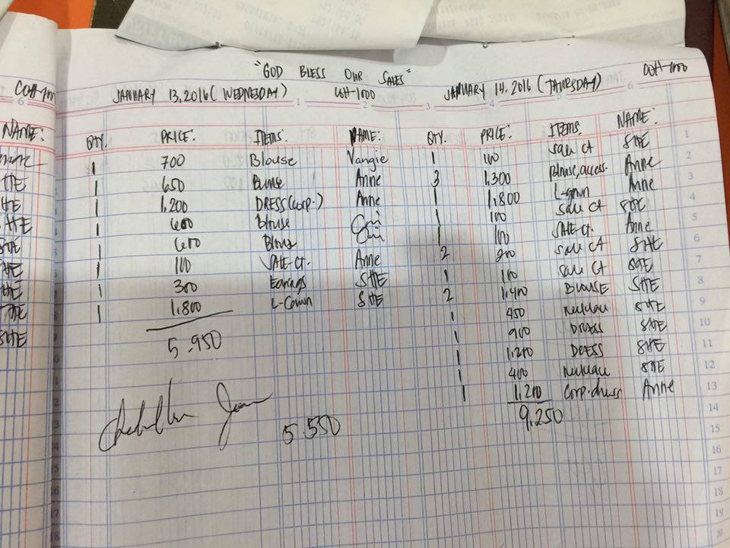

*Figure C-1.0*

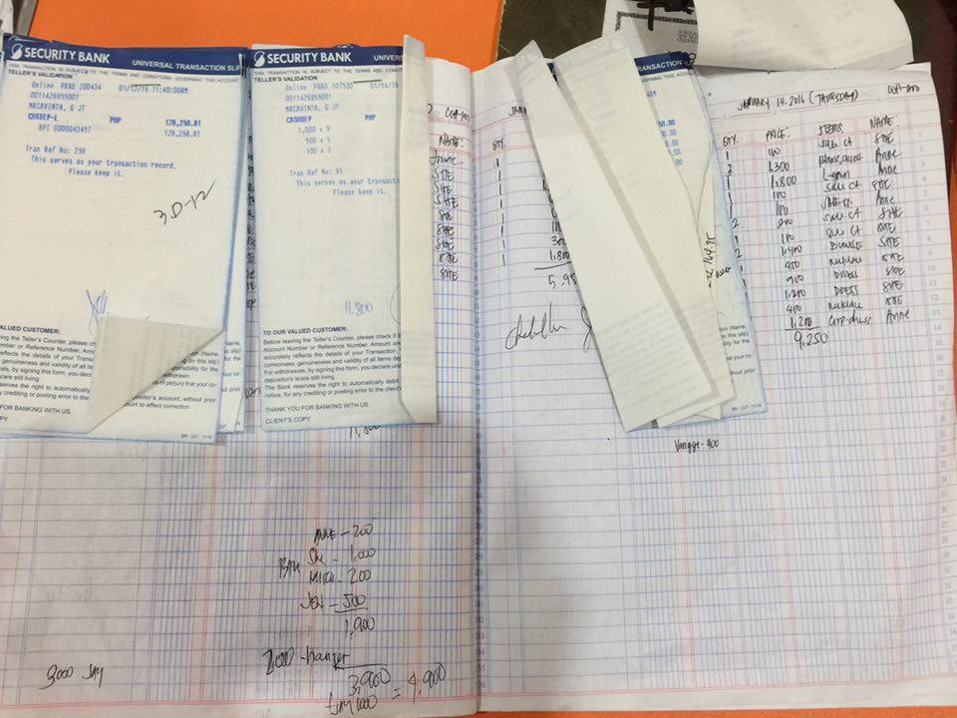

*Figure C-1.1*

*C-2. Daily Sales Logbook for retail stores*

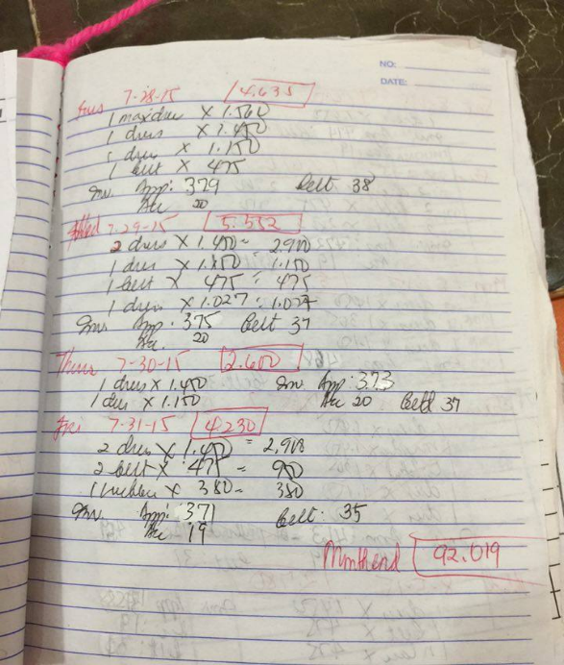The Daily Sales logbook is filled up by saleslady/owner for each transaction that the customer has made. This is also reflected to the copy of the owner. Shown in Figure C-2.0.

Figure C-2.0.

*C-3. Pull out order form*

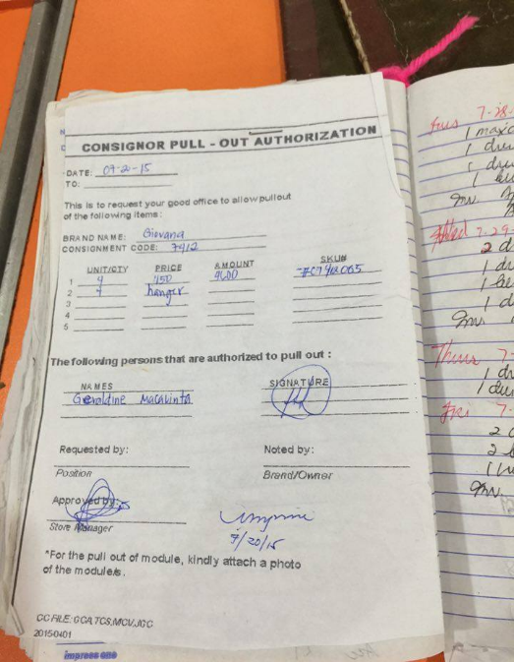The pull out order form is to be filled up by the staff from Cinderella that is checked by the owner of the company. Shown in Figure C-3.0

Figure C-3.0

*C-4. Monthly Sales Logbook*

The Monthly Sales logbook is filled up by owner that is the summary of the sales per month view. Shown in Figure C-4.0 and C-4.1.

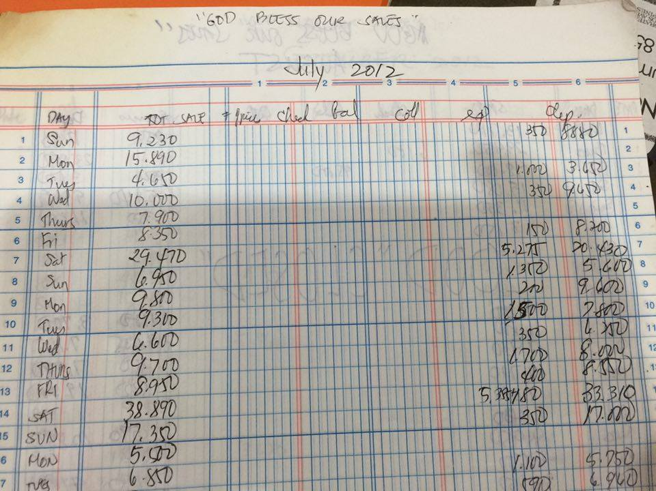

*Figure C-4.0*

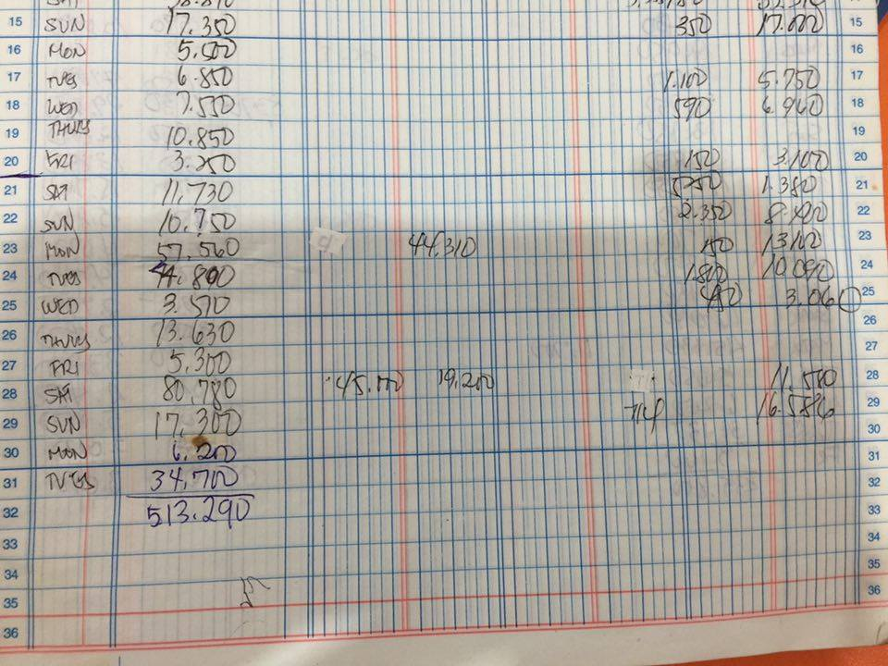

*Figure C-4.1*

*C-5. Yearly Sales Logbook*

The Yearly Sales logbook is filled up by owner that is the summary of the sales per year view. It also includes the summary of the sales for the bazaars. Shown in Figure C-5.0 and C-5.1.

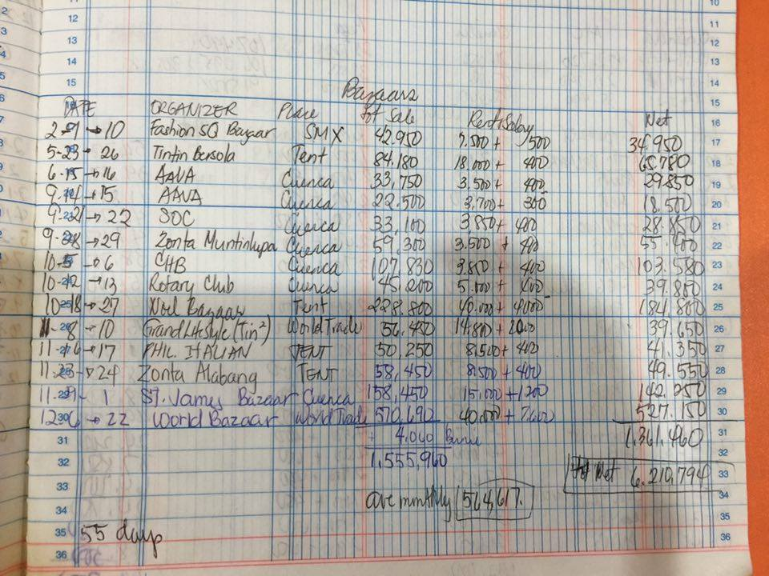

*Figure C-5.0*

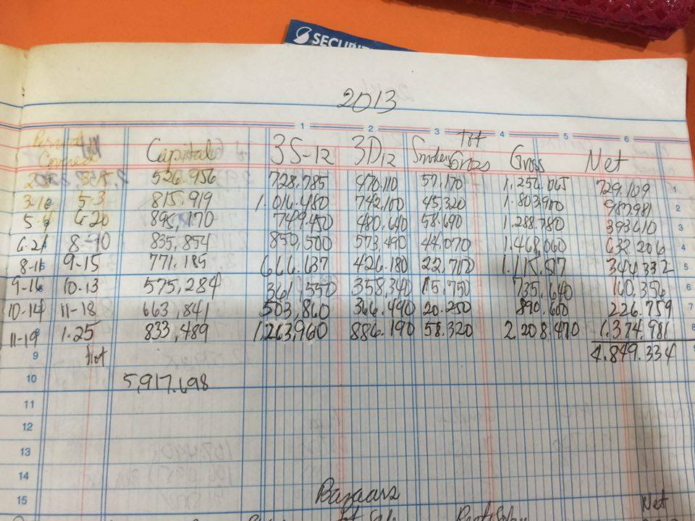

Figure C-5.1

**Appendix D – References and Acknowledgement**

The team would like to acknowledge Mrs. Geraldine Macavinta, the owner of Giovana Clothing Co. for helping us identify the problems in the current system she is using. She helped us understand the processes in her business.